CSA1715-ARTIFICIAL INTELLIGENCE
LAB PROGRAM- 10
30-07-2026
10. Write the python program to implement A* algorithm.

Aim
To implement the A* Search Algorithm in Python to find the shortest path from a start node to a goal node using heuristic values.

Algorithm
- Read the graph and edge costs.
- Read the heuristic value for each node.
- Read the start node and goal node.
- Add the start node to the open list.
- Select the node with the smallest f(n)=g(n)+h(n).
- Expand its neighbors and calculate their f(n) values.
- Repeat until the goal node is reached.
- Display the shortest path and total cost.
Program
graph={}
n=int(input("Enter number of nodes: "))

for i in range(n):
node=input("Enter node: ")
m=int(input("Enter number of neighbors: "))
graph[node]=[]
for j in range(m):
v,c=input("Neighbor and Cost: ").split()
graph[node].append((v,int(c)))

h={}
for i in range(n):
node=input("Enter node for heuristic: ")
h[node]=int(input("Heuristic value: "))

start=input("Enter start node: ")
goal=input("Enter goal node: ")

open=[(h[start],0,start,[start])]
closed=[]

while open:
open.sort()
f,g,node,path=open.pop(0)
if node==goal:
print("Path:",' -> '.join(path))
print("Cost:",g)
break
closed.append(node)
for nxt,cost in graph[node]:
if nxt not in closed:
g1=g+cost
f1=g1+h[nxt]
open.append((f1,g1,nxt,path+[nxt]))

Input
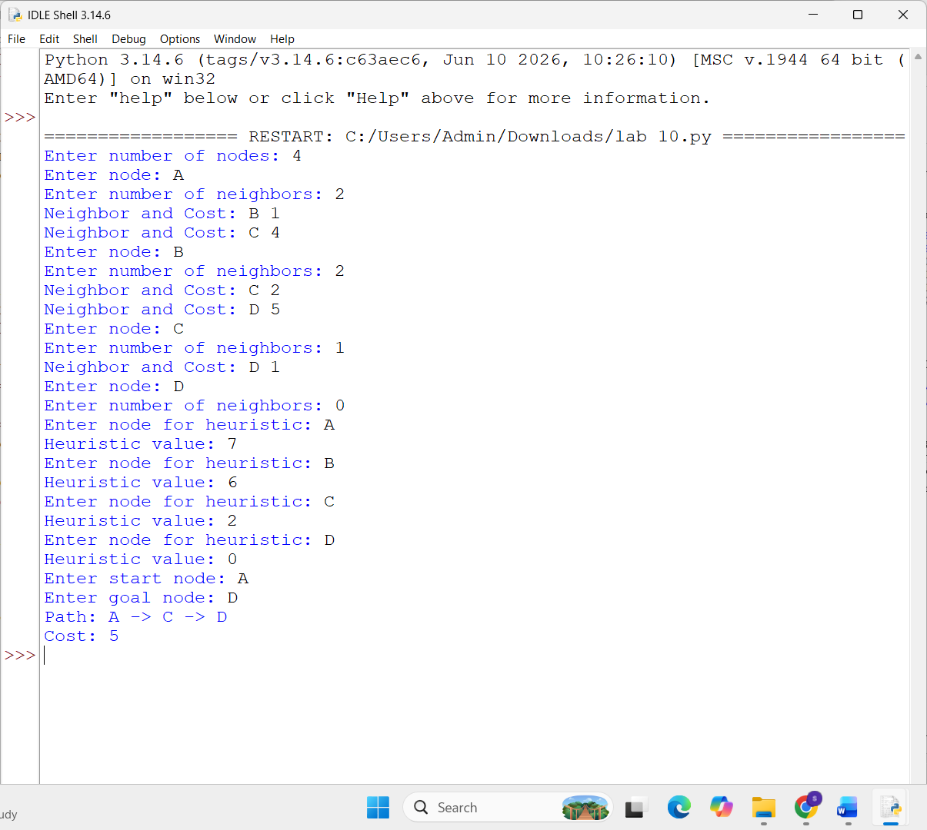
0utput


Result:
The A* Search Algorithm was implemented successfully. The program used the evaluation function f(n)=g(n)+h(n) to determine the optimal path from the start node to the goal node with the minimum cost.

